**How to use QCheckBox - An Example**

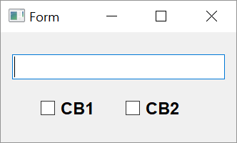

**Step 1**

**Morphing the widgets**

The design of form to show usage of checkbox widget is similar to radio-button example. Except, radio buttons are replaced by checkboxes. So, you can convert the radiobutton ui file from the previous section into a checkbox.

1. Open rbtn.ui with Qt designer.
2. Right click on the radio button and choose morph into->QCheckBox from popup menu.
3. Change object names to CB1 and CB2 respectively.
4. Save it as chkbox.ui and generate equivalent Python script chkbox.py.

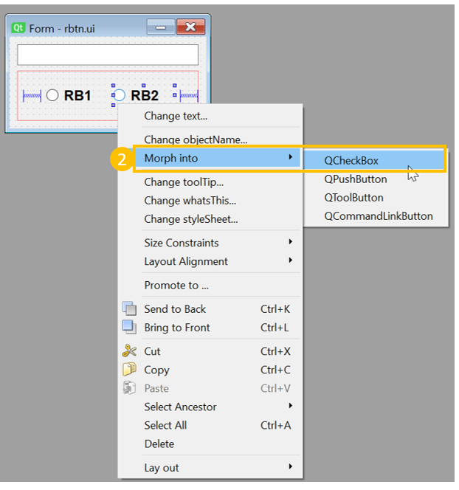

**Step 2**

Event Handling

1. Open chkbox.py with IDLE. Add following method in Ui-form class:   
     *def checkstate(self):  
   state1='Unchecked'  
   state2='Unchecked'  
   if self.rb1.isChecked()==True:  
     state1='Checked'  
   else:  
     state1='Unchecked'  
   if self.rb2.isChecked()==True:  
     state2='Checked'  
   else:  
     state2='Unchecked'  
   self.t1.setText("cb1 is {} cb2 is {}".format(state1,state2))*
2. Connect stateChanged signal of both checkboxes to this method.   
     *self.cb1.stateChanged.connect(self.checkstate)  
   self.cb2.stateChanged.connect(self.checkstate)*